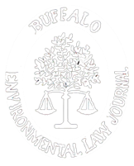
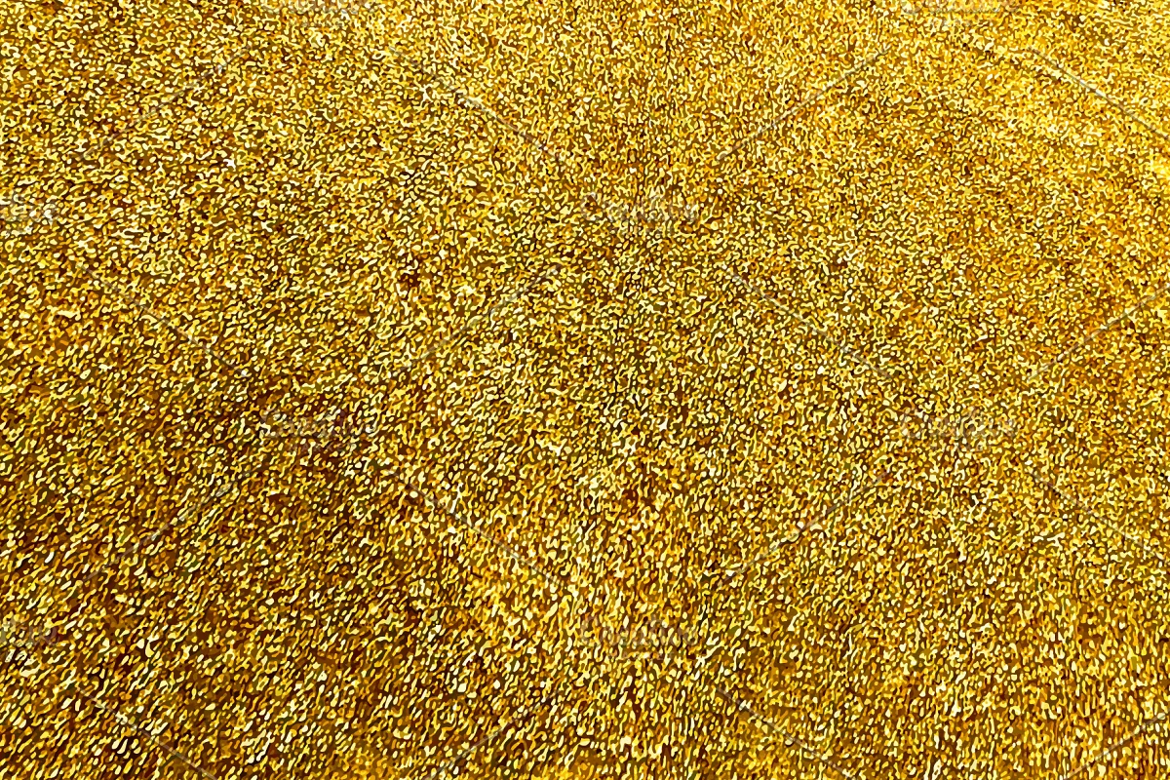
Buffalo Environmental Law Journal

Celebrating Thirty Years
1993 – 2023

Now Accepting Student Submissions for Volume 30

The Buffalo Environmental Law Journal is now accepting student submissions for Volume 30. Up to two student notes or comments will be selected for publication in Issue 1 (winter) or Issue 2 (spring). Our goal is to encourage students interested in academic writing and the field of Environmental Law to write on a topic that interests them and to give those students an opportunity to be published in an academic journal.
Current JD and LLM students enrolled in an ABA-accredited law school during the 2022-2023 academic year (and graduates one year out) are eligible to apply. Submissions should demonstrate original thought and ingenuity on an issue of significance relating to the field of Environmental Law. Submissions must be the original, unpublished work of the entrant. Submitted work may have been previously completed for academic credit but may not have been previously published in any form of media.
How to Apply
- Papers can be emailed to law-belj@buffalo.edu using the subject line “BELJ Student Submission” from now until January 8, 2023, at 11:59 p.m. (EST).
- Submissions must be in Word format. We encourage a length of 20-25 pages. Double-spacing and 12-point font is recommended. Please include page numbers.
- Please also include a brief abstract with your submission.
- Submissions should be written in traditional law review style, with full citation to authority included in footnotes, and conforming to the current edition of The Bluebook—A Uniform System of Citation.
- To maintain anonymity in the review process, no information that could identify the author should appear in the body of the paper, header, footer, or document properties.
- Please include a separate cover sheet in a separate electronic file, including the essay title; author's name; law school; expected year of graduation from law school; and author's mailing address, phone number, and email address.
- Participants acknowledge that the Buffalo Environmental Law Journal will not return any submitted entries. All entrants retain full copyright to their entries except that selected authors are required to license certain rights to the Buffalo Environmental Law Journal as a condition of publication.
Selection Process
Submissions will be judged on the following criteria: (1) writing quality; (2) analysis of the legal issue; (3) originality; (4) quality of research; and (5) the topic’s relevance to the field of Environmental Law.
Submissions will be judged anonymously, and selected authors will be determined by a committee selected by the Buffalo Environmental Law Journal Editorial Board.
The Buffalo Environmental Law Journal will select up to two papers to be published in Volume 30, Issue 1 (winter) or Issue 2 (spring). The Buffalo Environmental Law Journal reserves the right to select less than two papers for publication if it is determined that submissions are not of sufficient quality to merit publication.
Selected authors will be notified no later than January 15, 2023.
Please email submissions to law-belj@buffalo.edu no later than Sunday, January 8, 2023. Questions may also be directed to this email address. We look forward to reading your submissions!

