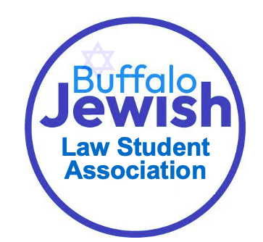
Jewish Law Student Association –(JLSA)

Executive Board

ALIZA BERGER
President

ALEXIS BUCKNER
Vice President/
Events Coordinator

DANIELA HOEGERLE
Parliamentarian

DAVID REINHARZ
Treasurer


Come schmooze with your favorite law school Jews!

Upcoming Events

Events | Details
General Interest Meeting | Monday, September 18 @ 5:15pm  O’Brian 106
Monthly Shabbat Dinner | Details to come
Jewish Speaker Series | Details to come

