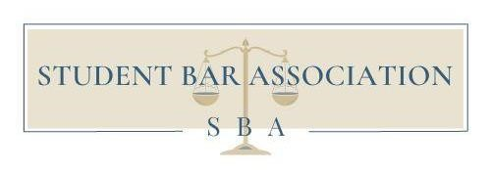
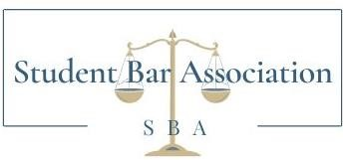
(716) 645-2748
Student Bar Association

Un
iversity at Buffalo Student Bar Association, Inc.

207
O’Brian Hall, Buffalo, NY 14260

law
-
sba@buffalo.edu

SBA Executive Board Meeting Agenda
October 4, 2023 @ 7:30 pm – Zoom

I. Opening Remarks / Call to Order
A. Hannah Johnston, SBA President, calls the meeting to order at 7:33 pm.
B. The topic of the meeting is to instate the Military Law and Veteran Association as a club under the Student Bar Association.

Attendance
A. Attendance 10.4.2023
1.Executive Board
  - Hannah Johnston - Present
  - John D’Aquino - Absent
  - Chloe Charles - Present
  - Tyler Myszka – Present
  - Giulia Buscaglia – Present
  - Emily Haley – Present
- 3L Directors:
  - Elizabeth Hughes - Present
  - Aliza Berger – Absent
  - Haley Muehlbauer – Absent
  - Delaney Shaw – Present
  - Glenae Garlock – Absent
  - Ron LaPort – Present

- 2L Directors
  - Thomas Mckenna – Present
  - Andrew Cegielski – Present
  - Katherine Kio – Present
4. 1L Directors:
  - Gianna Palumbo – Present
  - Lachlan Macintosh – Present
  - Henry Alaimo – Present
  - Parizoda Nasimionova – Present
5. 1L Alternate Directors:
  - Julia Hoffmann - Present
  - Nadine Sallaj – Present
6. LLM/2 Year JD Director:
  - Andrei Amedeo Zmarandoiu – Present

New Business

No new motions on the floor
- Jonathan Whyte presented new club: Military Law and Veterans Association
  - Get involved with the veteran services, host events, bring people of the same interests together and support those who have served, are serving, or plan to serve
  - Budget
  - Questions/Comments for Jonathan Whyte
    - No questions at this time
- Hannah asks Jon to step out
- Hannah calls it to a vote
  - All in favor:
    - Gianna Palumbo
    - Lachlan Macintosh
    - Henry Alaimo
    - Parizoda Nasimionova
    - Andrei Amedeo Zmarandoiu
    - Thomas Mckenna
    - Andrew Cegielski
    - Katherine Kio
    - Elizabeth Hughes
    - Delaney Shaw
    - Ron LaPort
    - Hannah Johnston
    - Chloe Charles
    - Emily Haley
    - Guilia Buscaglia
  - All opposed:
  - Abstained
    - Tyler Myszka – he is a part of the club
- Hannah instates the MLVA and the club is ratified

- Meeting Adjournment
  - Hannah Johnston adjourns the meeting at 7:37 pm.

