Hannah Johnston
Candidate for President

Hello! My name is Hannah Johnston and I am the current SBA President. I have greatly enjoyed my time as President, and especially working towards receiving extensive COAL funding for law school organizations, speaking with administration on how to bolster student wellness, and continuing to prioritize the events that mean most to students. If re-elected, my goals would be to make sure student needs are being met within and outside the law school, create closer relationships with other professional schools, work towards creating a comprehensive plan to deal with changing university healthcare requirements, and provide more support to student organizations. I hope you will consider me to represent you!

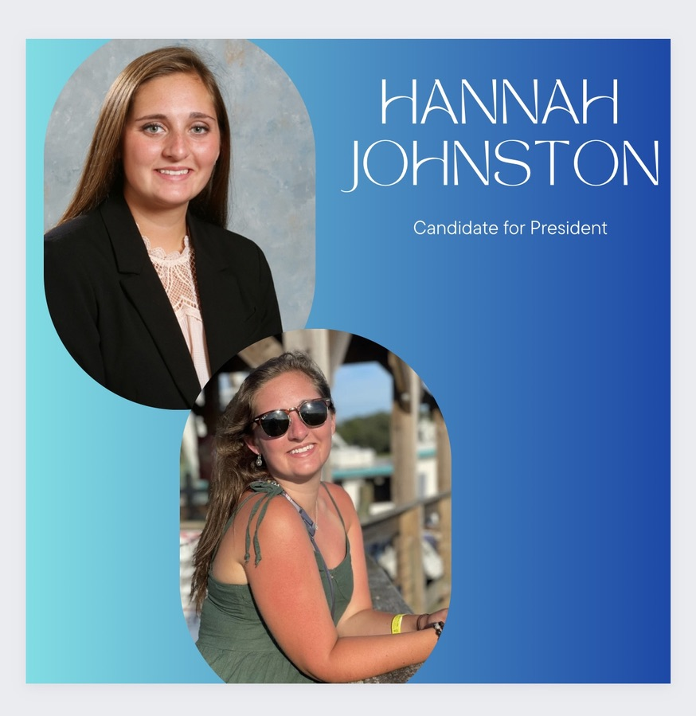

Richard Neri
Candidate for President

Richard is an enthusiastic first year looking to actively engage with everyone. We should not just come to lectures and go home. Richard strives to create a community throughout the halls of O’Brian. 1L sections rarely intermingle, nor do the different classes. Building a community between everyone can create a shared experience for us all to enjoy and benefit from.

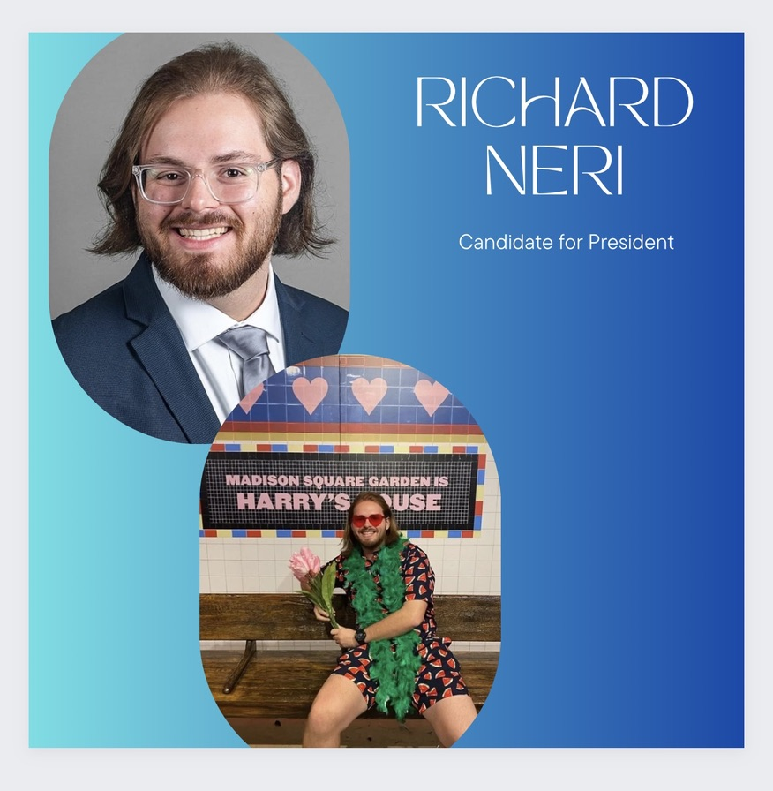

Chloe Charles
Candidate for Vice President

Hi, I'm Chloe Charles, and I'm excited to run for Student Bar Association Vice President! Having served on SBA this past year, I've gained valuable insights into the administrative processes and student preferences. One recurring issue we've encountered is with merchandise. As VP, I aim to collaborate with the school to introduce engaging merchandise that truly resonates with students' desires. Additionally, I'm committed to enhancing the efficiency of the SBA to ensure that students' needs are met. My goal is for students to look back and be proud of their decision to support me!

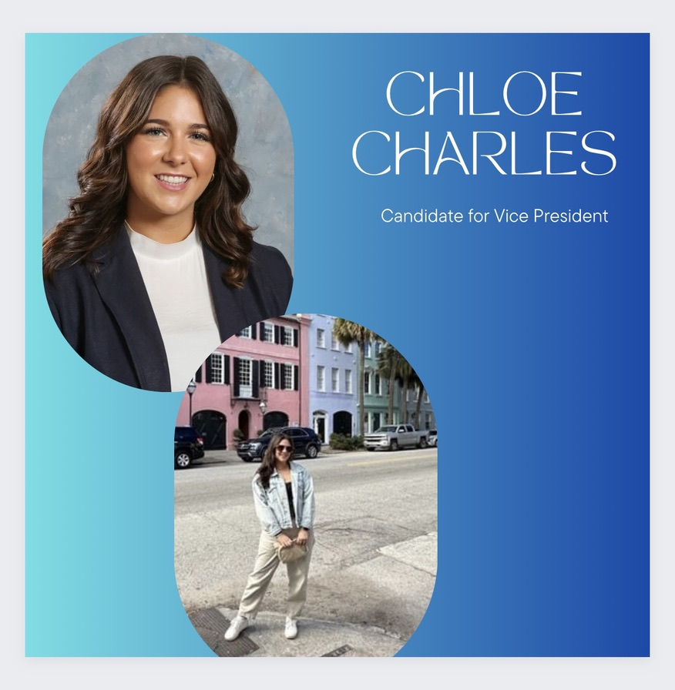

Andy Cegielski
Candidate for Events and Fundraising Cordinator

Hello UB Law!
My name is Andy and I would love the opportunity to be your Events and Fundraising Coordinator. I am ready to manage all SBA social events and investigate more sources of funding for the SBA as a whole.
I have a passion for planning events where everyone can have a great time. A great event to me is planned with the interests of the invitees, well attended, and with no detail left unconsidered. I will plan great events for the SBA.
I have a passion for seeing frequent events in our school- I love a full Docket. I want each SBA club to have the funding they need, to hold the events they want. I will work alongside our clubs to seek out fundraising opportunities to meet your goals. I am excited at the opportunity to work on your behalf and have a fun '24-'25 school year!

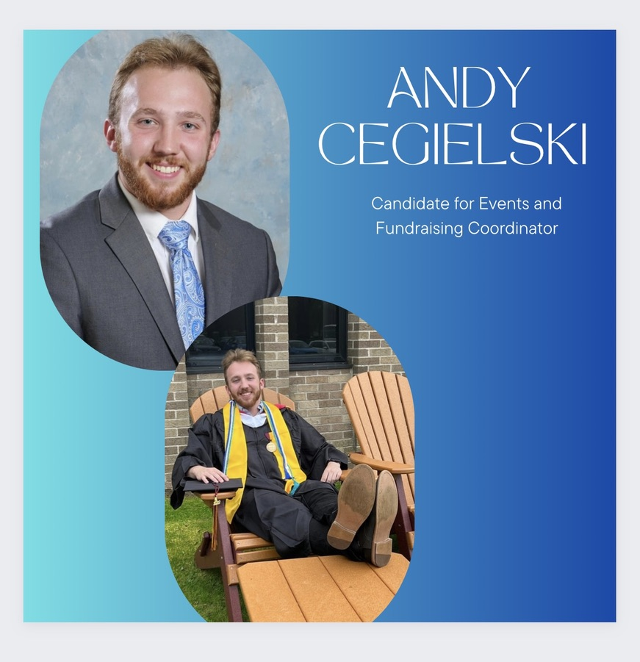

Henry Alaimo
Candidate for Treasurer

Henry is a 1L who has a background in project management and legal administration, he has budgeting experience particularly with large construction development projects. He is running for treasurer so that the SBA is able to provide law students, and their organizations with smart and economical financial support. Outside of law school Henry enjoys the outdoors, fishing, cooking, and sports.



