
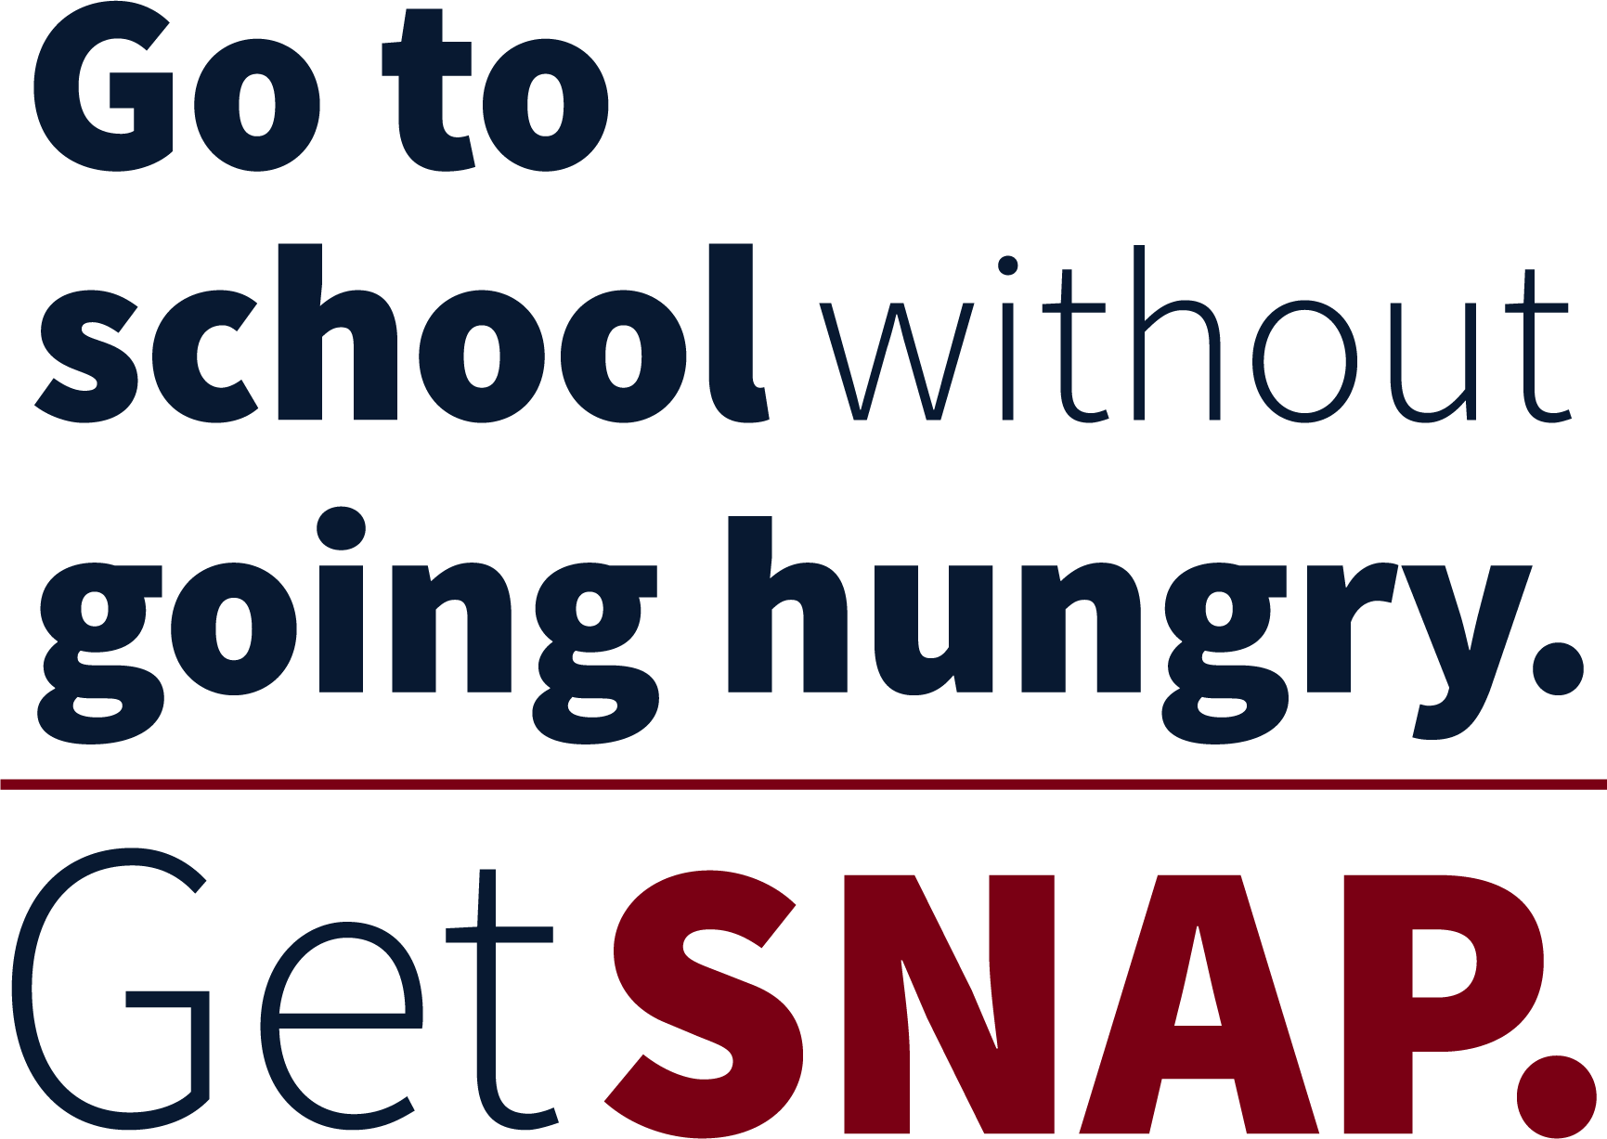
Tuition. Books. Food. You need all three to get your degree.
Hunger is strongly linked to lower graduation rates. SNAP may be able to help students, like you, get the food you need to succeed.
The Nutrition Outreach and Education Program (NOEP) can help you learn
if you may be eligible for SNAP. Our local NOEP coordinator can also help you complete and submit your application.
Call 716-645-2837 x 0 to check eligibility and make a free 20-min. appointment at Health Promotion:
Wednesday 9/4 10am to 2pm
Thursday 9/5 10am to 2pm
Wednesday 9/11 10am to 2pm
Thursday 9/12 10am to 2pm
Monday 9/16 10am to 2pm
Prepared by a project of Hunger Solutions New York; funded by NYSOTDA and USDA/FN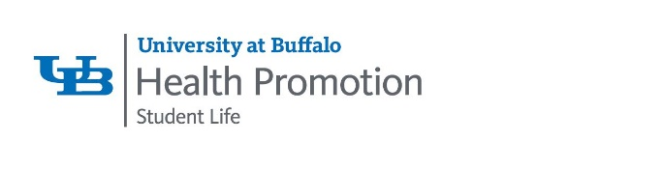S.
This institution is an equal opportunity provider.

