

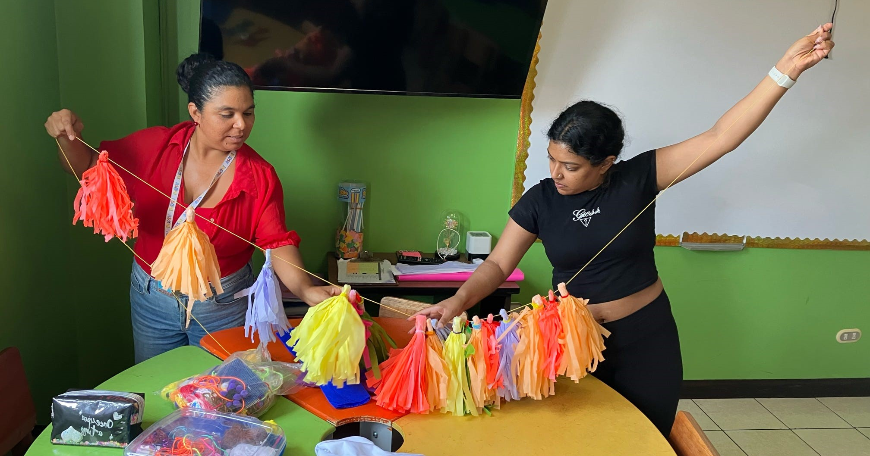

Learn more and apply
“We had the unique privilege of being let into a world that is unlike any world I’ve ever seen.” — MSW Student Alisa Chirico
UNiversity at Buffalo School of Social Work presents:

Costa Rica: UN SDGs, Human Rights & Global Action (Study Abroad, 3 Credits)
The United Nations Sustainable Development Goals (SDGs) address some of the world’s major challenges. With Costa Rica as a focus, students will see how the SDGs are part of the global language among governments, multilateral organizations, non-governmental organizations (NGOs) and businesses, and the role social work plays in achieving transformational change.
REGISTER: Spring semester 2025
APPLY: buffalo.edu/educationabroad (program fees apply)
TRAVEL: March 14-22 (approximate)
For more information, email Dr. Filomena Critelli at fmc8@buffalo.edu or
Dr. Laura Lewis at lalewis@buffalo.edu

