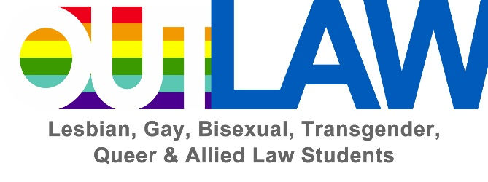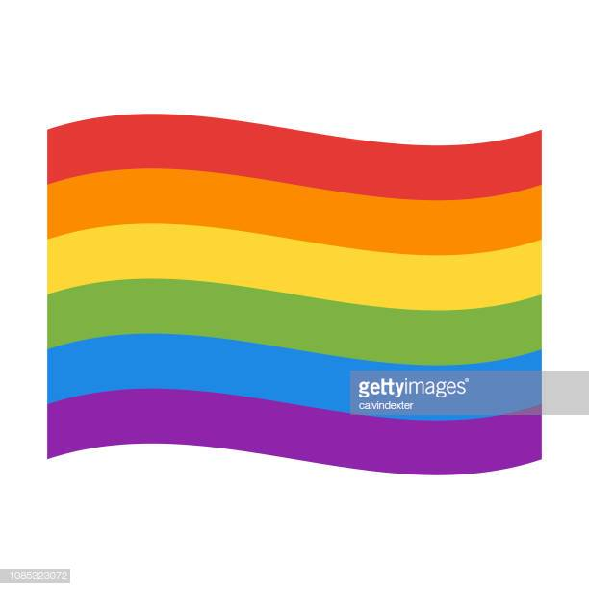
With support from the Student Bar Association
PLEASE JOIN OUTLAW
IN CELEBRATING
NATIONAL COMING OUT DAY
THURSDAY OCT. 10th

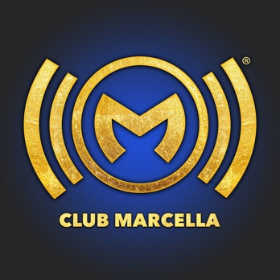
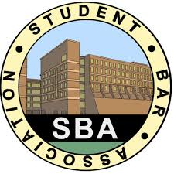
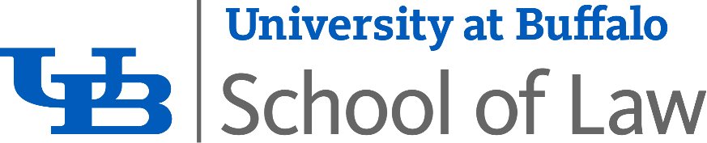
*Doors Open Exclusively for Law Students at 9pm*
Drink Specials all night!
Drag Show at Midnight & More!!
. . . Law Students are Reminded to Drink RESPONSIBLY . . .

At Club Marcella
439 Pearl St., Buffalo, NY 14202

Tickets can be purchased at the FSA ticket office or online for $10 up until the time of the event and for $15 at the door until 10pm

