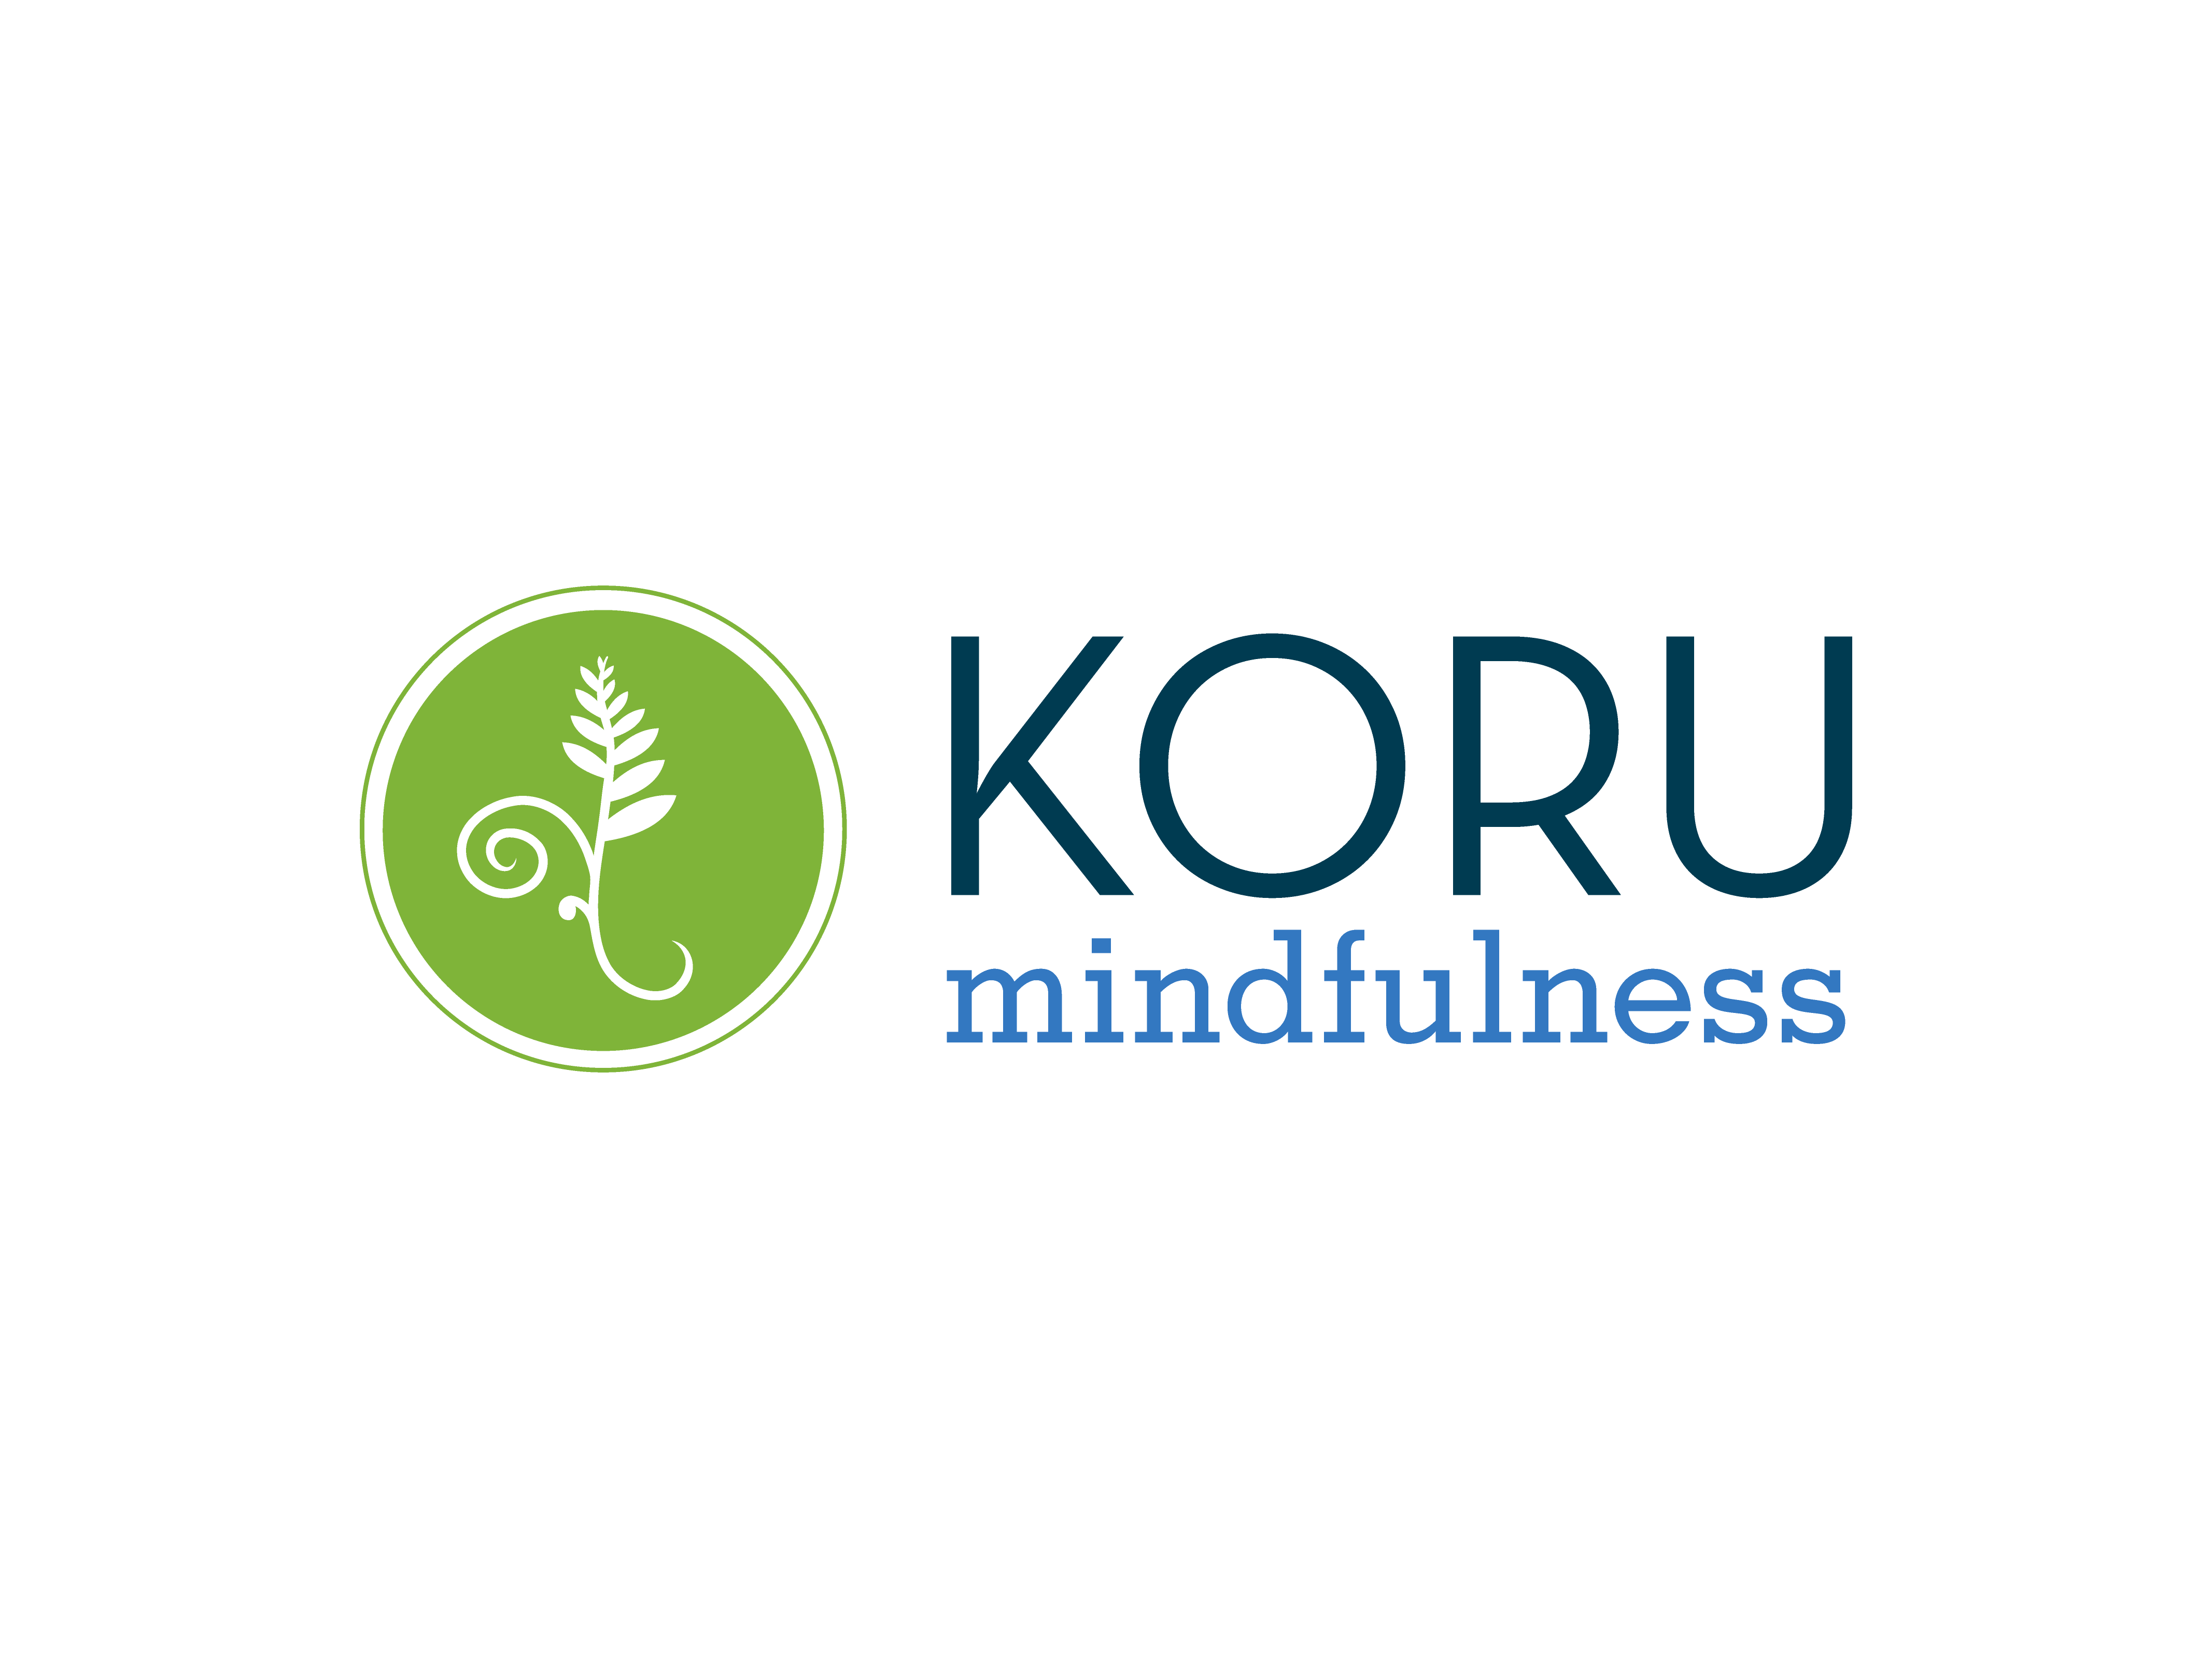

UB Koru Mindfulness Program Outline

Welcome to Koru! During this program you will be introduced to the practice of mindfulness and learn several skills, including meditation, for managing stress and enriching your life.

Mindfulness is about developing the ability to be fully attentive to all the moments of your life, reducing the amount of time you spend worrying about the future or fretting about the past. An important aspect of mindfulness is developing a non-judgmental, accepting, even curious, attitude about your moment-to-moment experience. The more you develop this attitude, the less you might feel overwhelmed by changes and challenges in your life.

Koru is designed to introduce you to the practice of mindfulness and get you well on your way to developing this important skill. Like learning any new skill, it takes practice to get comfortable with mindfulness. We invite you to devote yourself to the study and practice of mindfulness over the next four weeks, and we challenge you to stay curious about what evolves for you as you persistently and patiently practice living mindfully.

Program Information:
To participate in the Koru Mindfulness and Meditation Program for UB Students, you will need to attend all 4 sessions. See the Health Promotion page in UBLinked for specific class dates and times.
Staff Instructor Contact Information:
Sharlynn Daun-Barnett, LMSW, NBC-HWC
Wellness Coaching, Stress Management & Smoking/Vaping Cessation Programs, Health Promotion
114 Student Union, sd62@buffalo.edu, 716-645-6939 (office)

Some requests:
Please let us know if you won’t be able to attend a session.
Please turn off cell phones and other electronic devices when you enter the room for class.
Please be punctual. We will end each session promptly at the scheduled time.

Disability Inclusion Statement:
This program seeks ways to become a working model of inclusion and universal design for all UB students. Individuals with disabilities or chronic health conditions who require reasonable accommodations to participate in this program should speak to the instructor as soon as possible. Every possible effort will be made to accommodate you in a timely and confidential manner.
In order to deepen your learning, we are asking you to:
- Practice a mindfulness skill/meditation for at least 10 minutes every day
- Log your daily meditation and two things you are grateful for in the Koru app logbook
- Select a mindfulness activity to practice each week and log it in the Koru app logbook. This is an activity that you normally do mindlessly (e.g. tooth brushing, washing the dishes, etc.) that you try to do with full mindfulness instead
- Read the assigned chapters in the book for each session

Assigned Readings:
If you are able, please read the following pages of the text, The Mindful Twenty-Something (2016) by Holly Rogers, to prepare for each session:
Session #1 Part 1 and 2, p. 1 - 71
Session #2 Part 3, p. 72 - 117
Session #3 Part 4, p. 118 – 154
Session #4 Part 5, p. 155 – 181
This text can be purchased online as a book or e-book. It can also be downloaded from the UB Library at this link https://ebookcentral-proquest-com.gate.lib.buffalo.edu/lib/buffalo/detail.action?docID=4717650
(Note: If you are not able to do all of the readings before each session that is not a problem. The most important thing is to join us for the meditation practice time and discussion each week.)

The sessions and homework practice:
In each session you will learn 2-3 mindfulness-based skills and you will practice meditation with the help of your instructor(s). You may use any of the skills or meditations we teach for your daily ten minutes of mindfulness practice. Typically you will practice with skills during the week after we learn them in class. However, the goal is not for you to become expert at all the skills. Rather, the goal is for you to find one or two mindfulness practices that resonate with you, and work with those practices in greater depth. Everyone is different and will find different practices more or less helpful. Your task is to identify the skills that work for you and to spend your time developing, as best you can, your ability to use those skills.

- The Koru Mindfulness App has the recorded guided meditations that you learn in each session on it. Log your daily meditation practice in the app to track your progress. This app is available in the Apple App Store and Google Play for both Apple and Android devices.

- Insight Timer is a free app that may also help you with your daily practice. It has a timer function that will ring when your meditation time is done and will track your meditation sessions over time. It has hundreds of guided meditations and music tracks provided by international experts to determine what works best for you.

- The Center for Koru Mindfulness Website: http://korumindfulness.org/ has the guided meditations that you will learn each session under the “Student Resources” tab. You may use this to practice the skills we learn in class or to assist you with your daily 10 minute practice.

The First Session:

Skills: Two Breathing Exercises

Belly or Diaphragmatic Breathing—is a calming skill that you can use to calm yourself if you are feeling anxious or to quiet your mind to help with sleep. You will be taught to breathe deeply, inhaling by using your diaphragm to push your stomach out rather than using the muscles of your chest wall to fill your lungs.

Dynamic Breathing—is a very active skill that you can use if you are restless, anxious or tired, and need a way to focus your attention and energize your body. Students use dynamic breathing when they are tired or worried and still have lots of work to finish.

Meditation: Body Scan. In this meditation you will learn to use physical sensations in the body to anchor your awareness in the present moment.

The Second Session:

Skill: Walking Meditation. When practicing walking meditation, you learn to use as your anchor to present-moment awareness, the sensations in your feet as you slowly walk across the floor/ground. Students use walking meditation when they are too sleepy or too restless to meditate sitting still.

Meditation: Gatha. A gatha is a series of words, sometimes referred to as a meditation poem, that you use to help you focus your mind during meditation. Many students find that their minds wander so much that they can’t keep their attention in the present for even a moment. A gatha provides you with a stronger anchor for your wandering mind. Students use gathas when they feel very distracted and unable to settle their attention on their breath.

The Third Session:

Skill: Guided Imagery. Guided imagery is a way of calming your body and mind if you are feeling particularly anxious or stressed. Using all of your senses, you imagine yourself in a comfortable and safe place, which allows your physiology to quiet and calm. Students use guided imagery if they are dealing with high levels of stress or worry.

Meditation: Labeling Thoughts. An important aspect of mindfulness meditation is the ability to notice your thoughts and then, without judgment, release them, returning your attention to your object of meditation, most commonly the sensation of your breath as it enters and leaves your body. Labeling is a technique that makes it easier to release your thoughts and return to your present-moment experience. Student use labeling to strengthen their ability to stay non-judgmentally present with the goings-on in their busy minds.

The Fourth Session:

Skill: Eating Meditation. With eating meditation, you learn to pay very careful attention to all of the sensations involved in eating, as well as the thoughts and feelings you have when you eat. Eating meditation enhances the pleasure in eating and allows you to consume your food in a more healthy way, listening to the reactions and needs of your body.

Meditation: Labeling Feelings. This meditation builds on the labeling practice from last week, providing you a skill for managing strong feelings that may arise during meditation. Sometimes identifying the feelings that are underneath persistent or recurring thoughts can be very helpful, keeping you from getting carried too far away from the present moment.


The Koru Mindfulness and Meditation Program for UB Students is sponsored by the Health Promotion office. For more information about us, go to https://www.buffalo.edu/studentlife/health-promotion

