Buffalo Environmental Law Journal

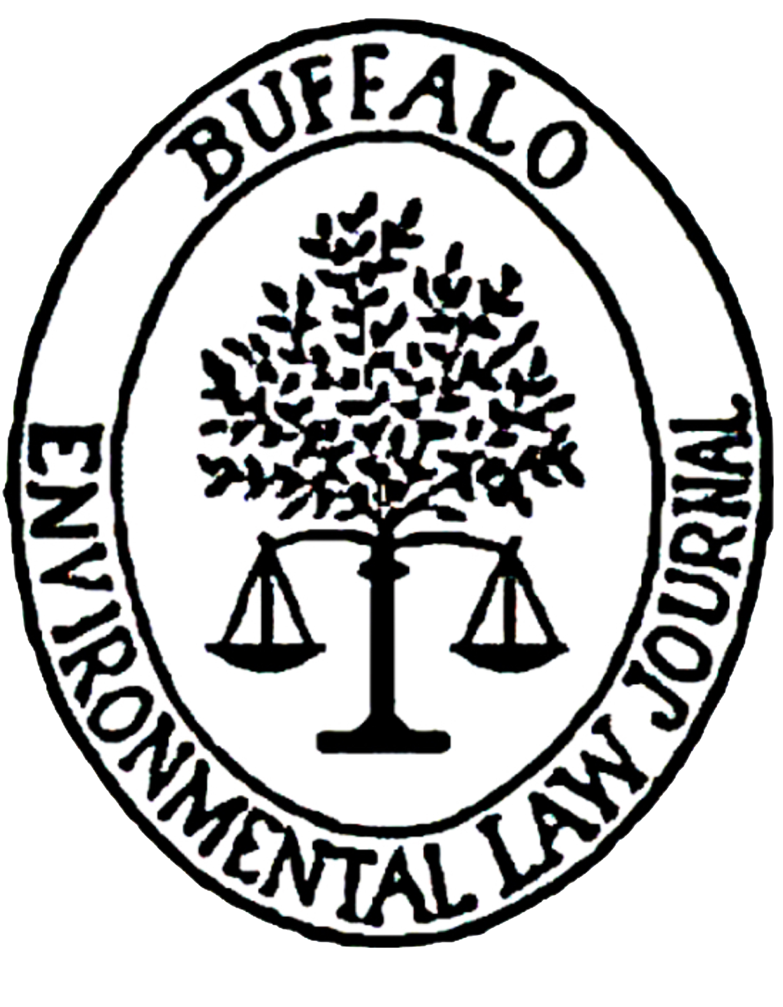

Associate Application
2022 – 2023

UNIVERSITY AT BUFFALO SCHOOL OF LAW

Dear Applicant,

Thank you for your interest in joining the Buffalo Environmental Law Journal as an associate for the 2022-2023 academic year.

To apply, please submit the following documents (in Word or PDF format) in the order listed below to Kristen Cascio, Editor-in-Chief, at kmcascio@buffalo.edu by Friday, June 10, 2022, at 5:00 pm:

- Cover Sheet/Grading Rubric
- Statement of Interest
- Resume
- Article Edits

- Textual Edits. Print pages six to eight from the application and edit the passage for grammar and punctuation. Make your edits in colored ink on the pages of the article. Alternatively, you may make your edits in a Word document by using the track changes feature. Assume all substantive content presented in the passage is true and supported by the footnotes (i.e., you do not need to check the sources for content).

- Bluebook Corrections (footnotes one through nineteen). In a separate document, re-type footnotes one through nineteen in accordance with the Bluebook (21st ed.). If you think you have found a discrepancy, use your best judgment in answering (you can also add a brief note explaining the alleged issue).

Late applications will not be considered. Offers to join the Buffalo Environmental Law Journal as an associate will be sent via email by the end of June. If you have any questions, please contact Kristen Cascio at kmcascio@buffalo.edu.

Thank you for your interest in joining the Buffalo Environmental Law Journal!

Sincerely,

The Editorial Board
Buffalo Environmental Law Journal

About the Buffalo Environmental Law Journal (BELJ)

The Buffalo Environmental Law Journal (BELJ) is a law review dedicated to publishing high quality articles on the most pressing issues facing our environment, including climate change, invasive species, energy policy, agriculture, and pollution. BELJ serves to expand the legal community’s understanding of environmental legal issues.

BELJ’s inaugural issue hit the presses in the spring of 1993. In 2023, we will celebrate the Journal’s 30th anniversary of publication. We are looking forward to an exciting year with special activities and events to commemorate this milestone.

The Associate Position

There are many benefits to joining BELJ. Our associates become members of the environmental legal community at UB and beyond. BELJ members achieve a deeper understanding of environmental legal issues, enhance their Bluebook citation and editing skills, help further the discourse on environmental law, and become more conversant in environmental topics. Associate responsibilities include editing academic articles, finding and retrieving source material, and correcting citations according to the Bluebook citation system, among other things. The BELJ atmosphere is friendly and supportive. New associates are given the tools to succeed and are mentored by returning members.

For more information about BELJ and the associate position, you can view the recording of our 2022 General Interest Meeting here.

If you have any questions or would like to learn more about BELJ, please contact Kristen Cascio, Editor-in-Chief, at kmcascio@buffalo.edu.

BUFFALO ENVIRONMENTAL LAW JOURNAL

COVER SHEET/GRADING RUBRIC

Please attach this sheet to the cover of your application.

Personal Information:

Name
Phone Number
Class Year
E-mail Address

Scoring (leave blank, for Journal use only):

Category | Value | Score
Textual Edits | 20
Bluebook Corrections | 60
Total | 80

ARTICLE EDITS INSTRUCTIONS

Edit the following passage for grammar and punctuation (the “Textual Edits”). Make your edits in colored ink on the pages of the article. Alternatively, you may make your edits in a Word document by using the track changes feature. Assume all substantive content presented in the passage is true and supported by the footnotes (i.e., you do not need to check the sources for content). A guide to proofreading and copyediting symbols can be found here.
Type the corrected footnotes in a separate document (the “Bluebook Corrections”). Corrections should be made in accordance with The Bluebook (21st ed.). If you think you have found a discrepancy, use your best judgment in answering (you can also add a brief note explaining the alleged issue).

For the purposes of this test, assume that all footnote sources support all statements in the text and that footnote “x” properly contains the Handl and ICESCR sources.
Grading:
One point will be awarded for each correct change to a footnote.
One point will be deducted for each unnecessary change.
Disclaimer: This text is adapted from a previously published article and the University at Buffalo asserts no copyright in the following work. A citation to the original work will be provided, upon request, at the close of the application period.
II. What International Human Rights Can Offer United States Environmental Law
To date, the primary avenue by which international environmental norms emerging from human rights theory have entered the United States legal discourse has been through Alien Tort Claims Act suits alleging that environmental wrongs violated the law of nations. The thrust of the argument has therefore been focused on whether there is a human right to a healthy environment. United States domestic courts have so-far resisted the invitation to find such a right, under either international human rights or in domestic constitutional rights, often concluding instead that the Legislative and Executive branches of government are better suited to establish environmental rights. A primary objection to the notion of recognizing independent environmental human rights is that ‘the evolution of environmental protection measures has involved a constant reordering of socio-economic priorities, of accommodating, adjusting or offsetting mutually restrictive if not exclusive public policy objectives.’ Among the major sticking points is the question of who would hold such a right and weather the right would have to account for future generations and group rights. In and ever-more integrated, globalized world, how would the the right to a healthy environment be enforced and would the right have any limits?
These are certainly important and interesting questions? However, there are other questions about these international law principles worth asking under United States domestic law. For example, as EPA uses its authority under the Clean Air Act to regulate greenhouse gas emissions, how should the agency confront questions of equity and justice, and how should it account for transnational impacts of climate change—all questions to which international human rights norms already speak.
A. An Introduction to International Human Rights
The idea of human rights-inalienable, universal rights to which all are entitled simply by virtue of being human—stands out as a significant achievement of twentieth-century legal thought. While the intellectual history behind human rights certainly traces its roots back to the Enlightenment, the specific principles we think of as human rights emerged from the more immediate and body context of Nazi genocide in the early decades of the twentieth-century Since the acceptance of the Universal Declaration of Human Rights in 1948, the concepts of human rights have increasingly been accepted as the governing norms for state behavior. Unsurprisingly in light of its moment of birth, the Universal Declaration responds to the central international legal challenge of the twentieth century—the proper limits of state power vis-à-vis individuals who are members of marginalized racial, ethnic or religious minorities. As such, international human rights law deals mainly with how people should be treated by government and its institutions. The International Human Rights Covenants and the proliferation of rights treaties that followed further detail the scope and reach of Human Rights described in the Universal Declaration.
B. Environmental Rights Under International Law
In making the argument that environmental regulators should rely on human rights to inform their decision making, it is important not to over state the relationship between human rights and environmental rights. Human rights and environmental protection trace their originals back to very different legal traditions and sources. To over-generalize, human rights are rooted in the natural law tradition in international law while environmental law is the product of a much more state-centered positive law tradition; More significantly, environmental law does not have protecting human beings qua individuals at its core in the same fashion that human rights law does. Indeed, environmental laws most distinctive feature is that it responds to the ramifications of human impacts on the natural environment. By contrast, even when envoked in the environmental context, human rights focus on protecting the human victims of environmental degradation rather than on protecting the environment itself. Human rights are, after all inherently anthropocentric. This distinction helps explain why the two legal discourses have evolved along very different tracks. That said, there are obvious points of intersection and overlap between environmental rights and human rights.

The Alien Tort Claims Act, 28 U.S.C. §§1350 (2006) (hereinafter ATCA); Filartiga v. Pena-Irala, 630 F. 2d 876, 888 (2nd Cir. 1980).
See e.g., Flores v. Southern Peru Copper Corp., 414 F.3d. 233, 256-262 (2d Cir. 2003) (affirming dismissal of ATCA environmental claim on the ground that the human rights to life, health and sustainable development were not yet definite enough to be jus cogens norms); Aguinda v Texaco, Incorporated, 142 F.Supp. 2d 534 (S.D. N.Y. 2001) (finding that Principle 2 of the Rio Declaration might constitute a binding international environmental norm but dismissing the case on forum non conveniens grounds); but see Séverine Fiorletta Leroy, Can the Human Rights Bodies be Used to Produce Interim Measures to Protect Environment-Related Human Rights? 15 Rev. Eur. Community & Int’l Envtl. L. 66, (2006) (arguing that human rights bodies are an appropriate forum to protect human rights).
Carole L. Gallagher, The Movement to Create an Environmental Bill of Rights: From Earth Day, 1970 to the Present, 9 Fordham Envtl. L. J. 107, 112-17 (1997).
Handl, supra n. x, at 121.
See John H. Knox, Climate Change and Human Rights Law, 50 Va. J. Int’l L. 163, 171 (2009).
Boyle, supra note x.
See Mary Ann Glendon, Tommy Lee, Grant Jacobs, and Ralph Thomas, Rights Talk: The Impoverishment of Social Discourse 14 (1991).
Art. 1, G.A. Res. 217 (III) A, Universal Declaration of Human Rights, U.N. Doc. A / RES / 217 (III.) A (December 10, 1948) [hereinafter “Universal Declaration"].
Amy Sinden, Climate Change and Human Rights, 27 J. Land Resources & Envtl. L. 255, 259-62 (Jan. 18, 2007).
Louis B. Sohn, The New International Law: Protection of the Rights of Individuals Rather than States, Am. U.L. Rev. 1, 16 (1982)
Universal Declaration, supra footnote 9.
See Eleanor Roosevelt, On the Adoption of the Universal Declaration of Human Rights http:// www.americanrhetoric.com/speeches/eleanorrooseveltdeclarationhumanrights.htm (Dec. 9, 1948).
See Pogge,Thomas, The International Significance of Human Rights, 4 J. of Ethics 45, 47 (2000).
ICESCR, supra note x.
Handl supra note x, at 120. See also Sohn, infra note 10, 16-18.
Richard J. Lazarus, Restoring What’s Environmental about Environmental Law in the Supreme Court, 47 U.C.L.A. L. Rev. 703 (2000)
Handl, supra note x, at 138-139.
See Dinah Shelton; The Links Between International Human Rights Guarantees and Environmental Protection 22 (University of Chicago, Center for International Studies, 2004), http:// internationalstudies.uchicago.edu/environmentalrights/shelton.pdf.
Philippe Sands, Sustainable Development: Treaty, Custom and the Crossfertilization of International Law, in International Law and Sustainable Development: Past Achievements and Future Challenges 43 (1999 Alan Boyle and David Freestone, eds.).

